**Math 120  
8.1 Sequences and Summation Notation**

# **Objectives:**

1. Find particular terms of a sequence given the equation for the general term.

# **Topic #1: Sequences**

*Introduction to Sequences*

A sequence is a string of numbers that follow a pattern or a rule to get from one term to the next. Consider the sequence:

$$2, 4, 6, 8, …$$

The first term is $2$, the second $4$, the third $6$, the fourth $8$, and so on. To get the next term, the pattern suggests to “add $2$”. The sequence goes on forever and is an

**___________________________**

Suppose that we were only interested in the first ten terms:

$$2, 4, 6, 8, 10, 12, 14, 16, 18, 20$$

This is now a **________________________** since there are a fixed number of terms (specifically, $n=10$ terms).

*Definition of a Sequence*

The terms of a sequence are a function of their position along the sequence. The first term is denoted as $a_{1}$ and occurs when $n=1$, the second term is $a_{2}$ and occurs when $n=2$, and so on. This gives the formal definition of an infinite sequence:

where $a_{n}$ is the $nth$ term and $n$ is a positive integer.

Each term is a function of its position along the sequence.

The domain is the set of positive integers $n$ and the range are the associated terms $a_{n}$.

The terms of the sequence:

$$2, 4, 6, 8, …$$

can be defined as $a_{n}=2n$, giving any term along the sequence as a function of its position:

when $n=1, { a}_{1}=2\left(1\right)=2$

when $n=2, a_{2}=2\left(2\right)=4$

when $n=3, a_{3}=2\left(3\right)=6$

when $n=4, { a}_{4}=2\left(4\right)=8$

Using the rule, the 99th term in the sequence is:

Note that we cannot evaluate the term of the sequence unless $n$ is a positive integer (also called a counting/natural number).

For example, values such $n=1/2$ or $n=-2$ is out of the domain since they are not counting numbers.

Here is a graph of the first ten terms of the sequence from the previous page. Notice that the domain is only $n=1,2,3,4,5,6,7,8,9,10$ and there are gaps between each term.

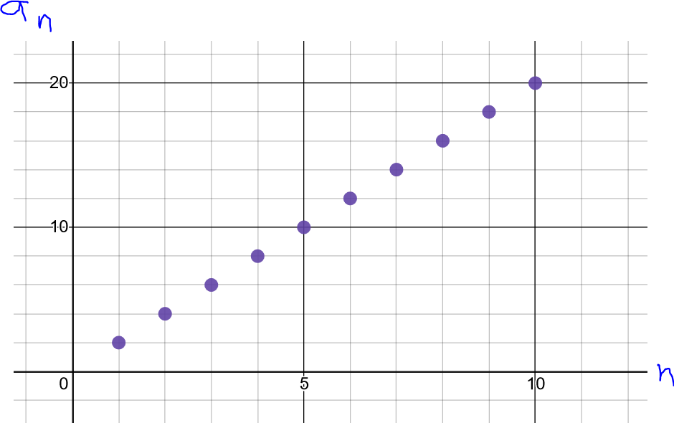

*Example #1* – Write the First 4 Terms of the Sequence

a) $a_{n}=5n+1$

Plug in each position into the definition to get its term:

when $n=1, a_{1}=$

when $n=2, a_{2}=$

when $n=3, a_{3}=$

when $n=4, a_{4}=$

Notice the next term is 5 more than the previous term.

b) $a_{n}=3^{n}$

Plug in each position into the definition to get its term:

when $n=1, a_{1}=$

when $n=2, a_{2}=$

when $n=3, a_{3}=$

when $n=4, a_{4}=$

Notice the next term is 3 times the previous term.

c) $a_{n}={\left(-4\right)}^{n}$

when $n=1, a_{1}=$

when $n=2, a_{2}=$

when $n=3, a_{3}=$

when $n=4, a_{4}=$

Notice the terms alternate between negative/positive and next term is $-4$ times the previous term.

d) $a_{n}={\left(-1\right)}^{n+1}\left(n-2\right)$

when $n=1, a_{1}=$

when $n=2, a_{2}=$

when $n=3, a_{3}=$

when $n=4, a_{4}=$

This is another alternating sequence.

$$\text{e) }a_{n}=\frac{2n}{n+6}$$

Plug in each position into the definition to get its term**:**

$$a_{1}=$$

$$a_{2}=$$

$$a_{3}=$$

$$a_{4}=$$

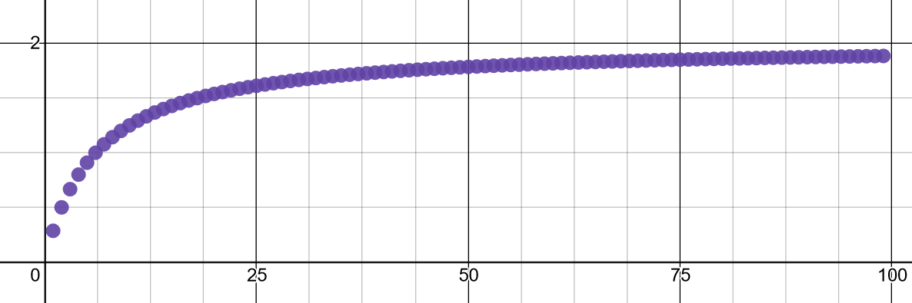

A graph of the first 100 terms shows they approach the value $2$ as $n$ gets bigger.